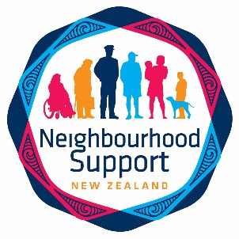
Top of the South Neighbourhood Support
Newsletter December 2020

TSNS newsletters are published monthly. Newsletter contributions are welcomed and need to be submitted by the 15th of the month before. They can be emailed, posted or dropped at our office.

PLEASE NOTE: The next newsletter will come out in February. Newsletters are being sent out to TSNS members directly. We kindly ask Street Coordinators to please print copies for those neighbours who do not have email, and drop them into their letterboxes. Please get in touch at admin@tsns.org.nz if this is a problem for you, a printable version will be attached to each newsletter. If you have already been in touch with us about this previously, then you will receive copies automatically. Thank you heaps for your assistance.

We now have a free 0800 phone service

0800 87 67 46

Top of the South Neighbourhood Support

Please check out our new website www.tsns.org.nz
Our new email addresses are:
admin@tsns.org.nz for Laknee Subasinghe
manager@tsns.org.nz for Katy Steele
aniquah@tsns.org.nz for Aniquah Stevenson the Waimea and Nelson Coordinator
charlotte@tsns.org.nz for Charlotte Wood the Marlborough Coordinator
Neighbourhood Support Nelson Tasman
Neighbourhood Support Marlborough

Charlotte Wood, Marlborough Coordinator
TSNS Launch in Marlborough: Thank you to everyone who came to celebrate with us on Friday 6 November at Dodson Street Beer Garden! We were delighted with the attendance and hope everyone enjoyed themselves as much as we did.
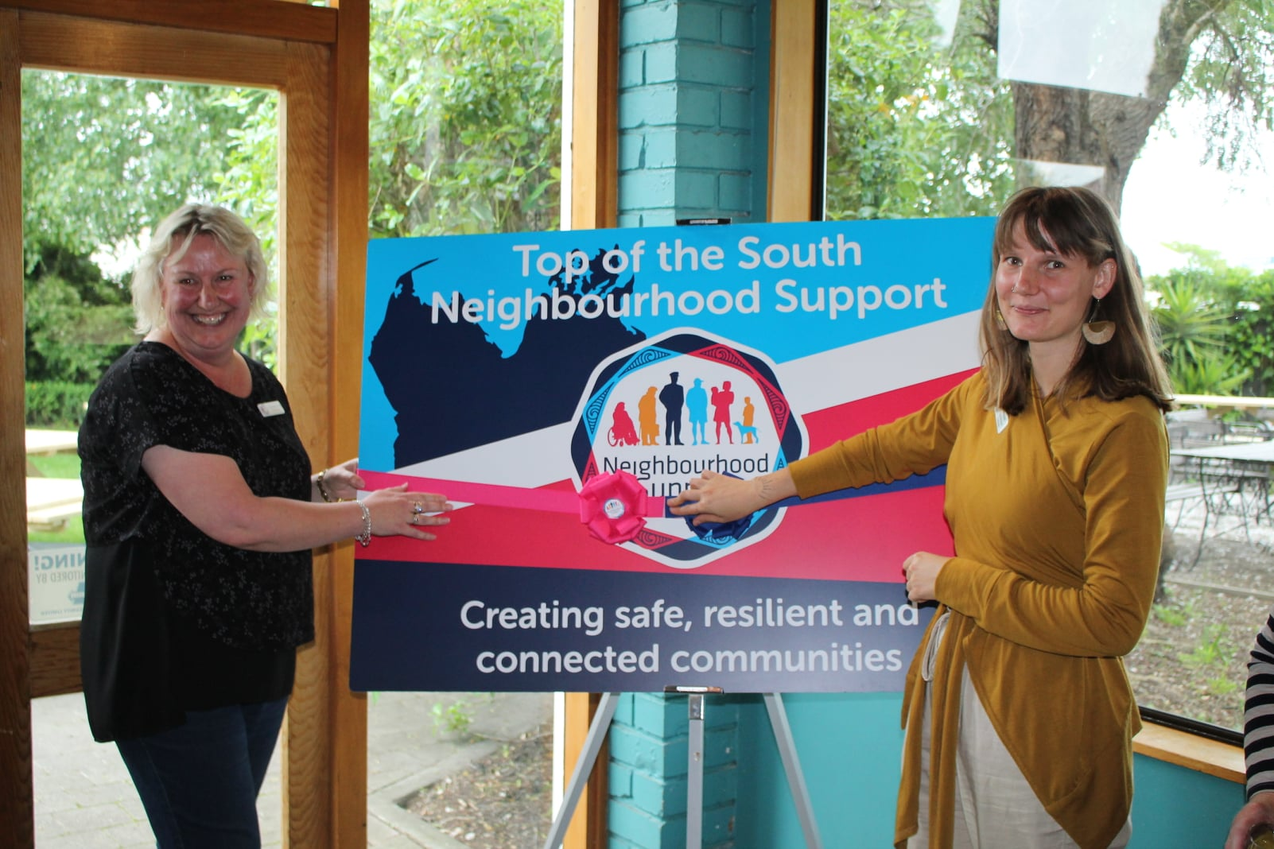

The national Neighbourhood Support campaign for the month leading up to Christmas is most appropriately... "The Joy of Giving." We rely on the generosity of our wonderful volunteer Street Contacts who selflessly give their time to coordinate their group and organise events for neighbours to connect. Thank you to you all! Neighbourhood Support simply couldn’t work without you!
Obviously volunteering in this way benefits the community, but did you know that volunteering can also help you to make new friends, learn new skills and may even advance your career? Volunteering can help you to feel healthier and happier, is good for your mind and body, and brings fun and a sense of fulfilment to your life! I challenge you to consider volunteering when you make your new year’s resolutions. Contact Volunteer Marlborough for many different ideas! Call in to see Meg and Hannah in Room 5 at The Community Centre, 25 Alfred Street, phone them on 03 577 9388 or check out their website https://volunteermarlborough.org.nz/
Gets Ready Training: Thank you to the four Street Contacts who attended the workshop on Gets Ready on Monday 9 November. It was a very hands-on session with plenty of time to practice adding details for new members and to find out what the database can do.

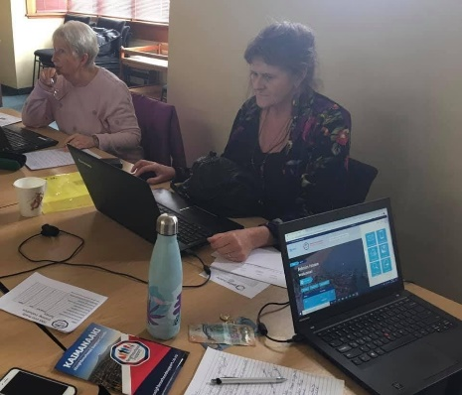
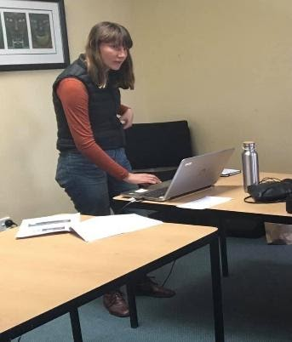

One attendee gave me this feedback: “I found it very helpful and it was good to hear a bit more about the website. I also thought it was a nice casual get together with other coordinators and was a great way to share what we all do – maybe we could all meet again for a cuppa and chat next year?”
What a terrific idea! So, in Marlborough throughout 2021, I will be running regular “drop in sessions” at 4 Wither Road. These will be for Street Contacts to call in with their laptops/devices and receive practical support with using Gets Ready, have a cup of coffee and connect with other TSNS members. Drop ins will be held from 10am to 11am every second month on a Tuesday morning, starting 19 January 2021. I will email reminders out to you via the Gets Ready database.
Tasman District Representative: I attended the Motueka Districts Neighbourhood Support AGM on Thursday 19 November. It was wonderful to meet everyone and hear about their priorities and projects. Thanks for the warm welcome everyone!
Christmas holiday: I will be taking some leave over the festive season to spend time with friends and family. My last 2020 working day for TSNS will be Tuesday 14 December, returning on Tuesday 5 January 2021. I wish you all a very Merry Christmas, safe summer holiday, as well as a happy and healthy new year! Remember to take care on the roads, be sunsmart and firewise, take care on, in and around the water.
We Are Seeking a Board Minute Secretary
The TSNS board meets monthly and they would greatly appreciate finding someone who is interested in attending these meetings and producing the minutes. The board meetings are usually on the third Tuesday of the month from 5pm to 6.30pm at the TSNS office.

The minutes are usually around two pages long and can be drafted on a laptop during the meeting. Alternatively, you can handwrite them and type them up after the meeting. If you are interested in this volunteer role, please do get in touch with Katy Steele on manager@tsns.org.nz or 021 074 7401 to discuss this further.
TSNS 2nd Annual Tahunanui Sand Sculpture Competition and Christmas Potluck BBQ with Multicultural NT
Top of the South Neighbourhood Support would like to invite young people and families to join us for a fun Sunday afternoon of free Kai and sculpting at Tahunanui Beach. Sculptors will be competing for a series of prizes to be announced on the lead up to the event. Join us for a free sausage sizzle and kai after! Check out the Facebook event here. Prizes are targeted towards young people and families but all are welcome to join the fun!
Multicultural Nelson Tasman, along with The New Comers Network will be hosting a Christmas Potluck in conjunction with our Sand Sculpture event, and will be taking place between 1pm – 5pm. More details coming soon!

Neighbourhood Resilience Planning Workshops
2020 sure has shown us the importance of building resilience at a neighbourhood level.

Apart from being kind and looking out for the immune compromised among us, TSNS wanted to develop a more strategic Neighbourhood Resilience Plan, utilising our new Gets Ready database and the expertise of Fire and Emergency NZ, New Zealand Police and NZ Civil Defence. Wednesday Nov18 was our last Neighbourhood Resilience Planning workshops for the year.

A special shout out to all volunteer Street Coordinators who have joined us for the Neighbourhood Resilience Planning workshop over the past couple of months, and a special thanks to Craig Piner and Gavin O'Donnell from FENZ, Hamish Chapman from Nelson Police, Vicki Bourke, NMIT Social Work student who was on placement with us, and the Top of the South Neighbourhood Support team Katy and Aniquah.

Follow us on Facebook or check out our website tsns.org.nz for next year’s line-up of workshops, projects, talks and much more!

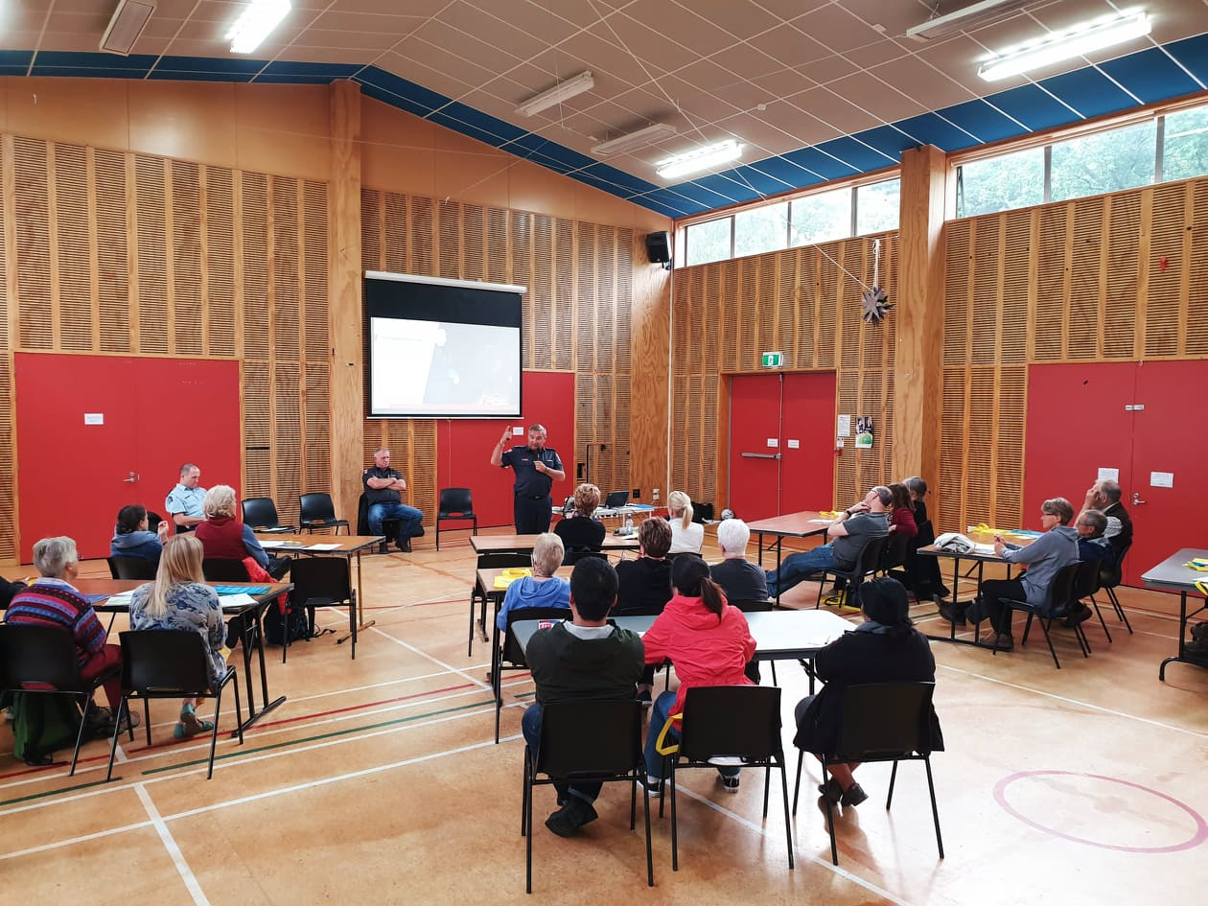
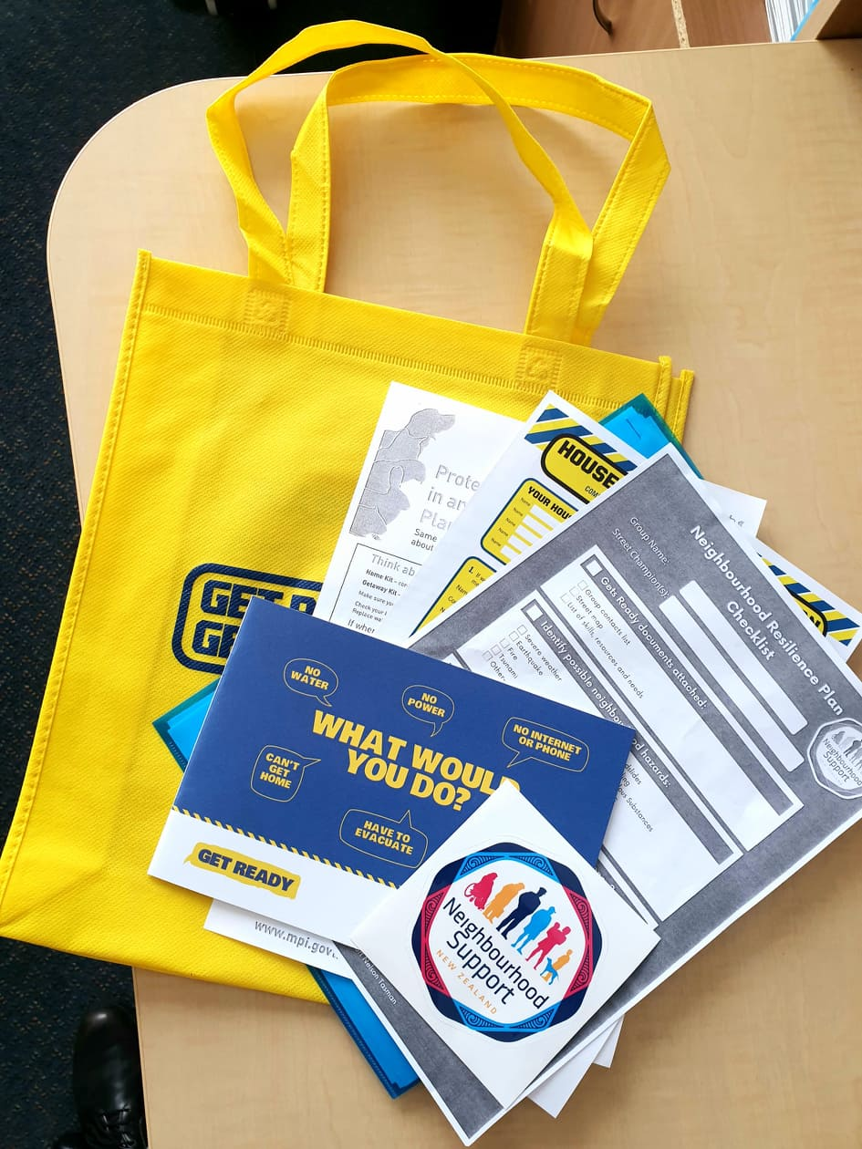

Observations from Waimea – Glenys Della Bosca

We have all heard the comment “I can’t wait for 2020 to be over” in reference to the Covid-19 experience. Well 2020 is nearly over and the rollercoaster ride has been really rough for some in our community. But of course, the ride does not end on New Year’s Day with a pandemic. So, we need to stay alert to protecting our community by observing health department protocols which have been shown to be effective. We each have responsibility here. It only takes one person to overlook these safeguards to be the weak link that lets Covid-19 in.
The measures are not hard – but they do need a willingness to take responsibility especially with scanning or signing-in to locations when we go shopping or attending appointments. Not everyone has a phone that can scan – but we can all sign-in. I know I am sometimes guilty of not taking my phone with me, but I’m trying to make it a habit because it is important to do so. All businesses are required to display a QR code and sign-in so please use them. And please, do not go to work or go shopping if you are feeling unwell.
Covid-19 was not the only change for Waimea – we also became part of the new Top of the South Neighbourhood Support Trust. Former Coordinator Marty Price was appointed to the new Board as a Trustee. Regrettably, personal circumstances have meant that Marty needed to resign that position. At this point I have not heard who has been appointed to the organisation in his stead. We trust that our other candidate is appointed to represent the best interests of Waimea.
With summer heating up, remember the basics – lock your doors, hide any shopping in your car, never lock a child or dog in your car over the summer as that could have a tragic outcome. If you are going away, coordinate with your neighbours to empty letterboxes etc to keep houses looking lived-in. I wish you all a happy and relaxed holiday season.

SCAM ALERT
There is a prevalent UPS package delivery scam making the rounds (see image) which you might want to alert your households to.
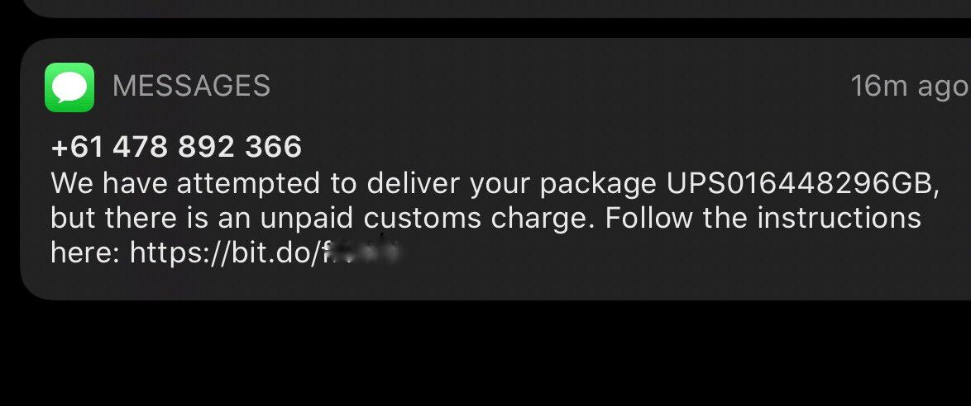
5 December: International Volunteers' Day

We, the staff at TSNS, would like to take the opportunity to celebrate International Volunteers' Day by saying a big thank you to all our volunteers. We greatly appreciate the time that you give to Neighbourhood Support and we recognise that we couldn't achieve what we do without you volunteers.

Street Coordinators, thank you so much for keeping in touch with people in your groups, encouraging people to get together and keeping contact details up-to-date. What you do is so important, as we recognise that an out-of-date database is not very useful in an emergency. Please do keep encouraging people to get onto the Gets Ready database.

Thanks too to office and event volunteers, again you greatly assist us, the few paid staff, to keep on top of all the jobs and enable us to get out into the community.

Finally, thanks to our board, who also contribute many hours to strategising, planning and developing TSNS for future success.

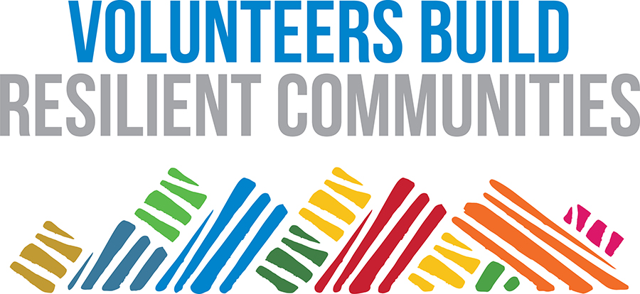

December National CampaignThe Joy of Giving

With many people feeling the pinch of covid19 restrictions, loss of income and the global economic downturn, how can your Neighbourhood Support group give back this season? As always, our recommendations are to check in and spend some social time with your socially isolated neighbours, this could include people in the community who are elderly, disabled, or even families with young children. You may also choose to put on a street BBQ, or simply bake your neighbour some festive treats!

Your Neighbourhood Support group may even want to do something for the wider community too. Why not volunteer at local community x-mas dinners, soup kitchens, or your local Foodbank. For Nelson Waimea members, get in touch with Volunteer Nelson to find out how you can help out this December season: volunteernelson.org.nz. You may also choose to collect food parcels from your neighbourhood to donate to local foodbanks and community centres, or why not participate in this years The Big Give 2020. More details here: https://www.thebreeze.co.nz/home/events/regions/nelson/2020/11/the-big-give-2020.html

Connected - www.connected.govt.nz/

Connected is a service to help New Zealanders connect to the wide range of Employment, Education and Training supports and advice available through government agencies.
Online Support for Emotional and Mental Wellbeing
It is perfectly normal to feel a little out of sorts during these strange times.
Yes, we are no longer in lock-down, however some of those close to you, and even your neighbours, may be feeling the financial stress of an economic downturn. It is important as neighbours to connect, be aware and support those who are vulnerable. If you notice a neighbour in need of support, we encourage the use of these online tools so that we can help each other through.
If you need to speak to someone over the phone, please call or text 1737
Need to make a non-emergency crime report?
Click on the link below to make a report or call 105

In an emergency, always call 111.

Scams

Nelson Police recommend using Netsafe New Zealand for advice regarding online scams and how to avoid them.

Follow us on Facebook to keep up to date with projects and campaigns.

Sponsors
Funders
Copyright © 2018 | Top of the South Neighbourhood Support | All rights reserved.
Our mailing address is:
PO Box 270
Nelson 2040
Email: admin@tsns.org.nz | Ph 021 074 7401

