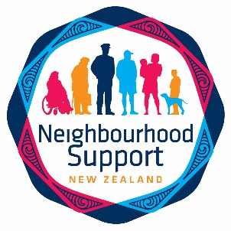
Top of the South Neighbourhood Support
Newsletter October 2020

TSNS newsletters are published monthly. Newsletter contributions are welcomed and need to be submitted by the 15th of the month before. They can be emailed, posted or dropped at our office.

PLEASE NOTE: Newsletters are being sent out to TSNS members directly. We kindly ask Street Coordinators to please print copies for those neighbours who do not have email, and drop them into their letterboxes. Please get in touch at admin@tsns.org.nz if this is a problem for you, a printable version will be attached to each newsletter. If you have already been in touch with us about this previously, then you will receive copies automatically. Thank you heaps for your assistance.

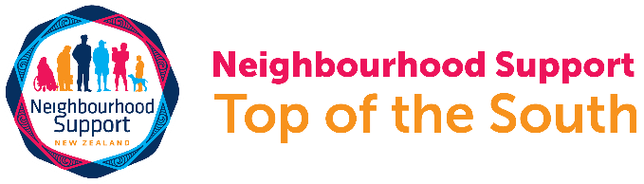

Top of the South Neighbourhood Support

Please check out our new website www.tsns.org.nz
Our new email addresses are:
admin@tsns.org.nz for Sarah Baldwin
manager@tsns.org.nz for Katy Steele
aniquah@tsns.org.nz for Aniquah Stevenson the Waimea and Nelson Coordinator
charlotte@tsns.org.nz for Charlotte Wood the Marlborough Coordinator
Neighbourhood Support Nelson Tasman
Neighbourhood Support Marlborough

Launching Top of the South Neighbourhood Support (TSNS) Nelson and Marlborough!
Exciting news! We are planning to formally launch TSNS, on Friday 16 October in Nelson/Waimea and Friday 6 November in Marlborough with both the Nelson and Marlborough Mayors respectively kindly agreeing to open the events. The events will be held at Savon Oval Lounge, Stoke and Dodson Street Beer Garden, Blenheim respectively and will be from 5 to 6.30 pm, drinks and nibbles will be provided. They will be Covid-19 levels 1 & 2 friendly.

There will be short speeches, refreshments provided and the opportunity to connect with others who support the aims of Neighbourhood Support; creating safe, resilient and connected communities. As we have limited funds, we will need to restrict the number of people attending. Street Coordinators, please email us on admin@tsns.org.nz if you, or a nominated person, from your street group would like to attend. We would really like you to celebrate with us.

Summer Social Connections: Meat and Bakery vouchers available
Having all experienced Covid-19 Alert Level 4 lockdown, we all value the support that we received from our neighbours, whether this was a chat, doing shopping or organising a physically distanced gathering. We think that summertime is a great time to get together and say thank you to each other. We have secured some funding from the Support for Volunteering Fund to provide food vouchers to enable groups to have a get together.

We still have some vouchers available, so if you are a Street Coordinator who would like either a $40 meat or bakery voucher for a Group social get together prior to Xmas, please do get in touch with us. These vouchers will be available on a first-come-first served basis.

Marlborough Members: Please fill in this form to secure a voucher for your Neighbourhood Support Group or email charlotte@tsns.org.nz.
Waimea and Nelson Members: Please fill in this form to secure a voucher for your Neighbourhood Support Group or email Aniquah@tsns.org.nz.
Need some inspiration? Check out the Neighbours Day Aotearoa website for resources and ideas: https://www.neighboursday.org.nz/

Neighbourhood Resilience Planning Workshops Nelson Waimea

Thank you to all volunteer Street Coordinators who joined us for the Neighbourhood Resilience Planning workshop on Wednesday 22nd of Sept. This marks the first of these workshops for 2020! A special thanks to Craig Piner and Gavin O'Donnell from FENZ, Hamish Chapman from Nelson Police, Vicki Bourke, NMIT Social Work student who is on placement with us, and the Top of the South Neighbourhood Support team Katy and Aniquah.

Would you like t to learn more about neighbourhood resilience, and..
The role of different emergency services
What to consider in different emergency situations: fire; earthquake etc
What the risks are and how to minimise them
Collecting information about neighbourhood skills, resources and needs

Our next workshops will be taking place at 7pm on the following dates:
Wakefield School Hall, 20th October.
Victory Community Hall, Victory Community Centre 18th November

These workshops will run during Covid-19 Levels 1 or 2. If you are interested please register with us, either by completing this form or emailing Vicki on vicki@tsns.org.nz.

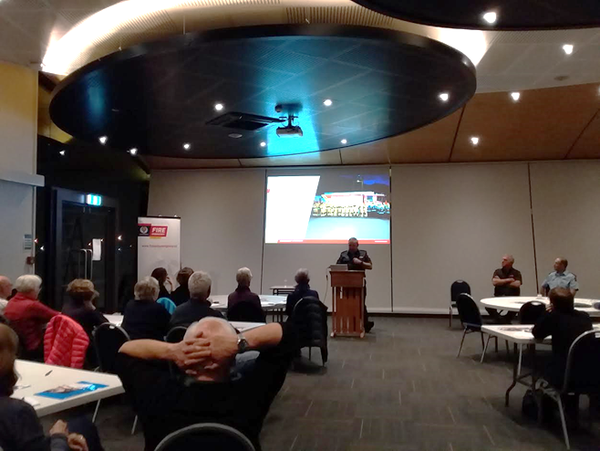

Marlborough Gets Ready Database Training
On Monday 9 November, from 1pm to 3pm at REAP Marlborough, 19 George St in Blenheim, we will be holding training for how to use our TSNS database called Gets Ready. This is especially useful for Street Coordinators as they can manage their members themselves through the database.
To register, call REAP Marlborough on 03 578 7848 or email admin@reapmarlborough.co.nz. Hurry, places are strictly limited! A $5 contribution to REAP’s cost is requested. Thank you.
*Please take your passport with you when you register at REAP for the database training. They need proof of your NZ residency as well as your date of birth. Thanks.
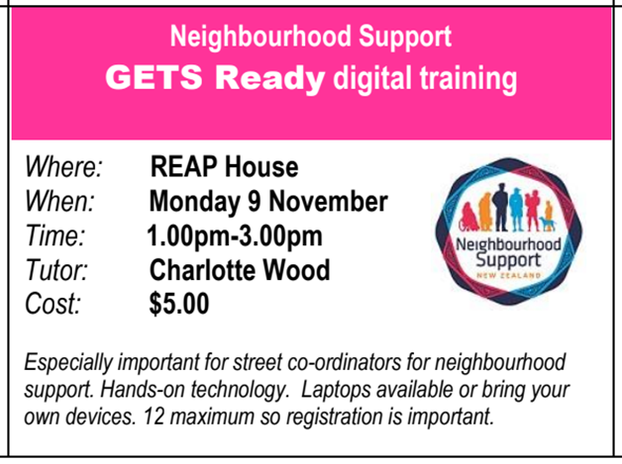

A message from Charlotte Wood, Marlborough Coordinator
The Neighbourhood Support national campaign for October is “Prepared for anything”. This highlights the importance of sharing emergency and disaster preparedness information within our communities.
On Thursday 15 October at 9.30am our national earthquake drill and tsunami hikoi will be taking place. You can find out more information about the NZ Shake Out, Whakahaumaru Aotearoa by clicking on the following link:
https://getready.govt.nz/involved/shakeout
Being based at the Emergency Operations Centre (EOC) at 4 Wither Road, we are lucky to have close working relationships with our friends at Civil Defence and Emergency Management (Marlborough CDEM).
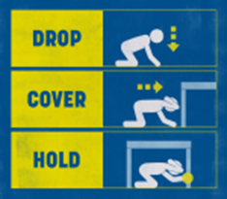
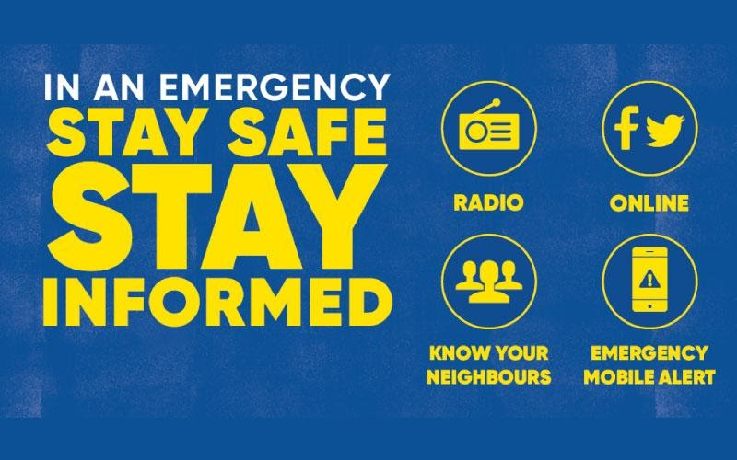
It’s very important to remember that in an emergency, the first people you will see WON’T be Civil Defence or the emergency services, it will be your nearest neighbours. So it’s really important to get to know them!
ShakeOut National Earthquake Drill and Tsunami Hikoi 15th October 9.30am
Sign up for your neighbourhood, school or workplace to take part.

When an earthquake happens DROP, COVER, HOLD.

All of New Zealand is at risk of earthquakes. Knowing the right immediate action to take can prevent injury and save lives. In an earthquake, Drop, Cover, Hold. It stops you being knocked over, makes you a smaller target for falling and flying objects, and protects your head, neck and vital organs.

• DROP down on your hands and knees. This protects you from falling but lets you move if you need to.
• COVER your head and neck (or your entire body if possible) under a sturdy table or desk (if it is within a few steps of you). If there is no shelter nearby, and cover your head and neck with your arms and hands.
• HOLD on to your shelter (or your position to protect your head and neck) until the shaking stops. If the shaking shifts your shelter around, move with it. If there is no shelter near you, crawl to an inside corner of the room and cover your head and neck with your hands and arms. Do not run outside or stand in a doorway. Many people are injured while trying to move DURING the shaking. It is safer to Drop, Cover, and Hold until the shaking is over.

Come to our Neighbourhood Resilience Planning training to be better prepared. See section below for more information.

Day Light Savings- Check your Smoke Alarms!

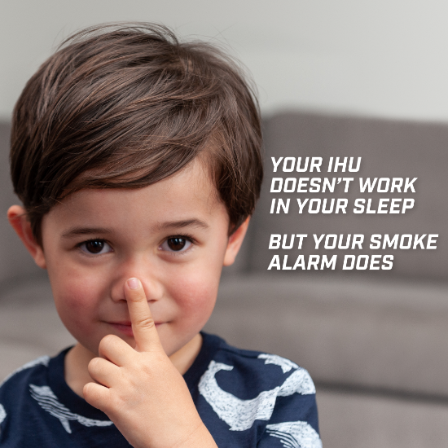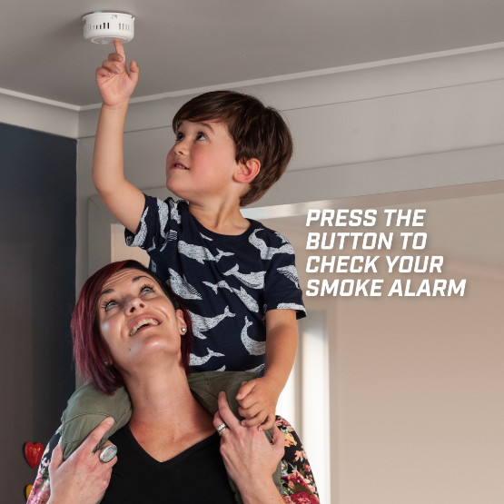
For more information visit Smoke alarms checking and maintenance

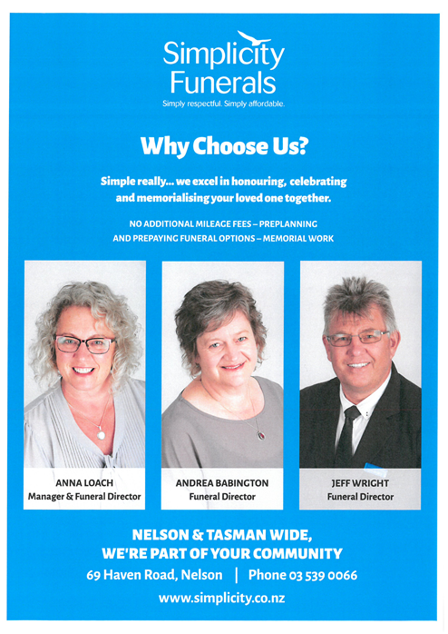

Observations from Waimea

Last month I, along with several other street coordinators attended the Gets Ready training workshop held at the Richmond campus of NMIT conducted by Coordinator Aniquah and TSNS Manager Katy. I found this to be a valuable experience and helped to familiarise me with the database we now use, called Gets Ready. Misconceptions were clarified, and we were each able to try out all the functions of the programme as they apply to us and learn about those used by Aniquah and Katy as administrators.
The ability to communicate with over 6500 households immediately throughout the Top of the South to distribute the monthly newsletter, advise specific areas of emergencies affecting them, to identify residents with specific needs or assets in the event of a disaster is valuable. Of course, it does not reach those who do not have access to the internet, but street coordinators usually know who in their street fits into this category and will go door-to-door, as necessary. In a nutshell, the ability to use these networks in times of emergency quickly and efficiently is one of the reasons that Waimea amalgamated with the other Neighbourhood Support groups.
So, I urge all street coordinators to attend one of these workshops when they are offered again if you possibly can. Not only will you learn about Gets Ready, you will be able to meet other street coordinators and compare experiences.
Glenys Della Bosca
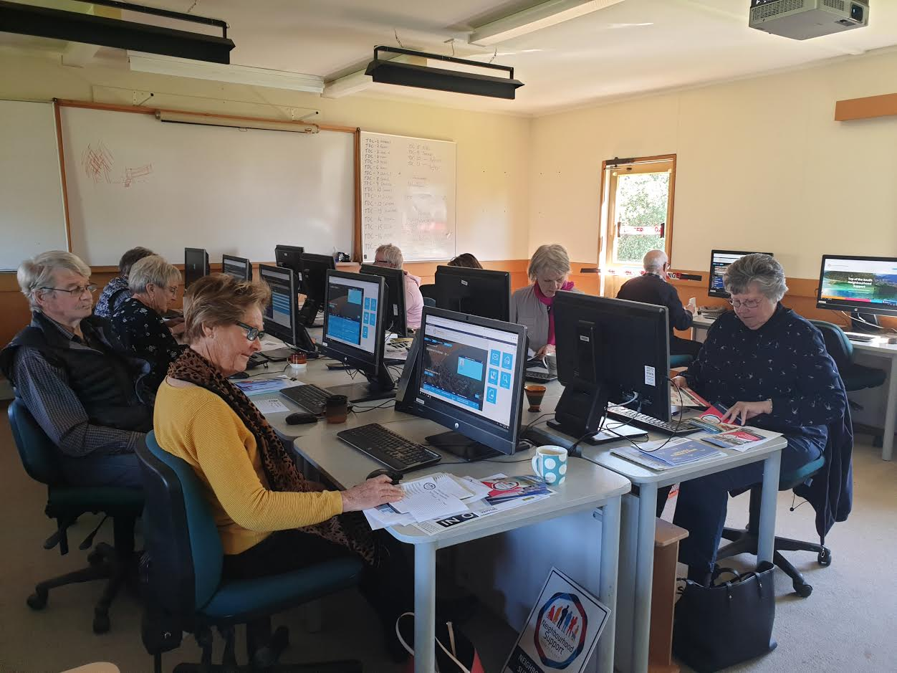

Connected - www.connected.govt.nz/

Connected is a service to help New Zealanders connect to the wide range of Employment, Education and Training supports and advice available through government agencies.

Online Support for Emotional and Mental Wellbeing
It is perfectly normal to feel a little out of sorts during these strange times.
Yes, we are no longer in lock-down, however some of those close to you, and even your neighbours, may be feeling the financial stress of an economic downturn. It is important as neighbours to connect, be aware and support those who are vulnerable. If you notice a neighbour in need of support, we encourage the use of these online tools so that we can help each other through.
If you need to speak to someone over the phone, please call or text 1737
Need to make a non-emergency crime report?
Click on the link below to make a report or call 105

In an emergency, always call 111.

Scams

Nelson Police recommend using Netsafe New Zealand for advice regarding online scams and how to avoid them.

Follow us on Facebook to keep up to date with projects and campaigns.

Sponsors
Funders
Copyright © 2018 | Top of the South Neighbourhood Support | All rights reserved.
Our mailing address is:
PO Box 270
Nelson 2040
Email: admin@tsns.org.nz | Ph 021 074 7401

